**MIKROTIK CONTROLLER**

1. Thành Viên:

* Phùng Nam Trung
* Phạm Vĩnh Đức Thịnh

1. Hạng Mục:
   1. Tìm kiếm API và tìm hiểu giao thức kết nối.
   2. Kết nối Mikrotik Controller tới Router.
   3. API Command.
   4. Script TXT thành một file JSON.
   5. Reset Configuration và Reboot Router.
   6. Walled-Garden.
   7. Wifi Marketing.
   8. NAT port.
   9. Password Encryted Generates.
   10. Mikrotik Router Status.
2. Mô Hình:

* Mikrotik Controller:

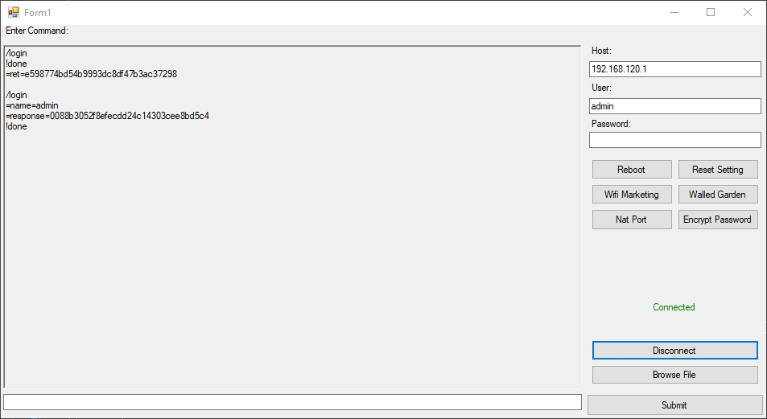

* Reset Configuration Dialog:

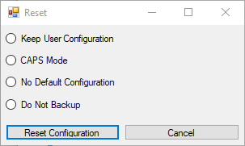

* Walled-garden Dialog:

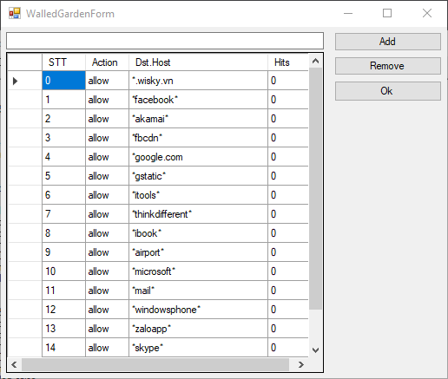

1. Chi tiết Hạng Mục:

|  |  |  |  |  |
| --- | --- | --- | --- | --- |
| STT | Tên Hạng Mục | Hang Mục Con | Tiến Độ | Chi Tiết |
| 1 | Tìm kiếm API và tim hiểu Winbox | * API, Protocol . | 100% | * API Tik4net. * Kết nối TCP/IP, MAC Telnet. |
| 2 | Kết nối Controller tới Router | * TCP/IP và Mac telnet. | 50% | * Hoàn thành kết nối TCP/IP. * Chưa hiện thực MAC Telnet.(API Không hỗ trợ kết nối bằng MAC Address). |
| 3 | API Command | * Command. | 100% | * Hoàn thành. |
| 4 | Script to JSON | * Tìm hiểu NewtonSoft Framework. * Chuyển nhiều file TXT thành một JSON | 100% | * Hoàn thành. |
| 5 | Reset Configuration và Reboot Router | * Button Reset. * Button Reboot. | 100% | * Hoàn Thành. |
| 6 | Wifi Marketing | * Cấu hình Demo trên Router. * Button cài đặt Wifi Marketing. | 100% | * Hoàn thành cấu hình trên Mikrotik Router. * Hoàn thành chuyển từ Mikrotik Command sang API Command. * Hoàn thành hiện thực. |
| 7 | Walled-Garden | * Thêm Walled-garden trên UI. | 100% | * Cấu hình walled-garden trên router * Hoàn thành lấy walled-garden từ router bằng API command. * Hoàn thành remove và add new host. |
| 8 | NAT port |  | 0% | * Chưa hiện thực. |
| 9 | Password Encryted Generates | * Tìm hiểu kỹ thuật hashing. * MAC + Secret Key = Password. | 0% | * Chưa hiện thực. |
| 10 | Mikrotik Router Status | * Lấy tình trạng theo Interface của router. | 0% | * Chưa hiện thực. |